A/Prof. Michael Stubbs
BDS MDS MDSc FRACDS MRACDS (Oral Medicine) FAAOM
Oral Medicine Specialist
Ground Level, Suite 1
124 Grey Street
East Melbourne VIC 3002
Telephone: (03)96632272

Template for Patient Information to assist in the Telemedicine Consultation
Patient Name
Date of Birth
Contact phone number

Medical History
Drug Allergies: Y or N If Yes, …………………………………………………………
Prescribed Medication: Y or N
if Yes………………………………………………………………………………………………………………………………………
Relevant Medical Conditions (Please fill in relevant condition)
Heart disease ………………………………………. Lung disease …………………………………………………
Thyroid disorder………………….. Diabetes………………………………. Osteoporosis……………………………
Gastrointestinal disorder (e.g. reflux; crohn’s disease) …………………………………
Artificial joints (including heart valve replacements) …………………………………………
Smoker Y or N if Yes, number of cigarettes daily ……………….. years smoked……………
Alcohol Y or N if Yes, …………………………… glasses per day

History of Complaint

…………………………………………………………………………………………………

…………………………………………………………………………………………………

…………………………………………………………………………………………………

…………………………………………………………………………………………………

…………………………………………………………………………………………………

…………………………………………………………………………………………………

…………………………………………………………………………………………………

………………………………………………………………………………………………..

Examination

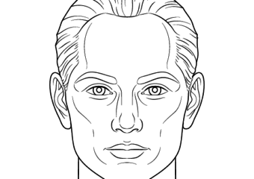

Highlight the areas where pain or area of interest for discussion

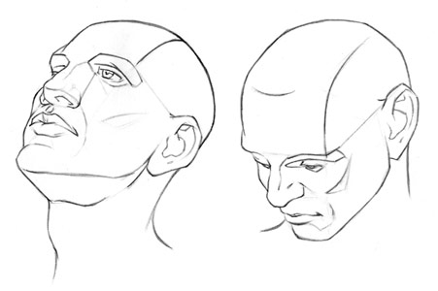
Radiology relevant to the case can be uploaded

Clinical Photographs relevant to the case can be uploaded

